*You are a world policy maker concerned about food security. You work for an organization such as the World Trade Organization, United Nations, Commission of Sustainable Agriculture and Climate Change, etc. You job is to gather data about the ability to achieve food security on a global basis, and to gain cooperation of the nations of the world to make global food security real and environmentally sustainable. Having access to food is a basic human right, or is it?*

**Background Information:**

* Free trade agreements exist between many nations that allow food crops, as well as other products to be freely imported and exported without taxes and tariffs or price fixing, and sold on an open, competitive market.
* Free trade agreements are generally good for big businesses, but leave small family owned businesses because they must compete in the free market and will be at the mercy of international prices.
* Small, local family farms have historically been the foundation of traditional rural communities and to global food security, but are being displaced by large, multinational agribusinesses.
* The idea behind free-trade agreements in that increased trade and decreased government regulation increases food security and solves rural food access problems. However, it removes control from local markets and places transnational corporations in control of the world’s food supply.
* Since NAFTA (North American Free Trade Agreement) was implemented in 1994, 38,000 small U.S. farms have gone bankrupt, 1.5 million Mexican farmers have lost their income, and 11% of Canadian farms are bankrupt.
* However, ADM, Cargill, and ZenNoah’s (3 of the largest agribusinesses in the U.S.) have made 3-4 times more profit each year, prospering greatly due to policies made the WTO, governments, and large agribusinesses.
* Food insecurity afflicts communities worldwide wherever poverty prevents assured food access.
* A third of food produced for human consumption is lost or wasted across the global food system.
* Over 1.04 billion people have fallen into extreme poverty, in part due to rising food prices, according to a UN Millennium Development Goals study, and 1 in 8 people in the world is chronically undernourished.
* Food systems must shift to better meet human needs and balance with planetary resources. This will demand major interventions, on local *and* global scales, to transform current patterns of food production, distribution, and production. Sustainable agriculture, improvement in supporting infrastructure, and restoration of degraded ecosystems are also needed.
* Humanitarian, environmental, and global security concerns demand a global commitment to improve the human condition.
* Key recommendation of the Commission on Sustainable Agriculture and Climate Change:

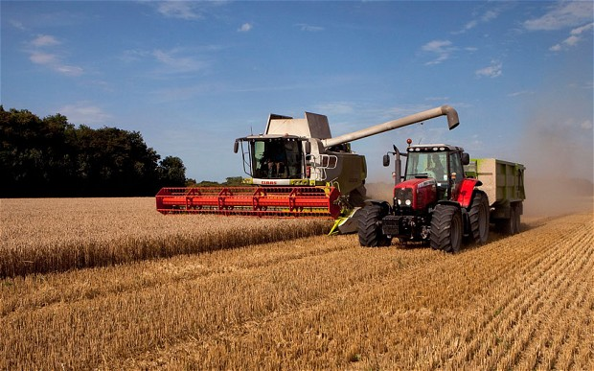

<http://i.telegraph.co.uk/multimedia/archive/02765/harvest_2765354b.jpg>

* 1. Integrate food security and sustainable agriculture into global and national practices.
  2. Significantly raise the level of global investment in sustainable agriculture and food systems

With increasing global wealth comes the increase consumption of meat and dairy products. These

are less efficiently produced because more calories go into the animal feed, so more crops are

grown as animal feed than human food.

If the crops for animal feed and other non-food uses went to food use, 4 billion more people

could be fed.